Stonelands Autumn Show was held on Sunday 7th September in a new venue in Ashburton, Devon. Open showing took place after the working and bull X championships had taken place. The Lurcher ring was judged by Mr Simon Parr, who awarded Sarah Doble’s ‘Inca’ puppy champion with Kevin Loft’s ‘Ottis’ taking reserve, with large class entries the title of Lurcher Champion and the final place in the Devon Champion of champions went to Paul Studdy’s ‘Alfie’ with John Crosslings ‘Alfie’ taking Reserve Champion.
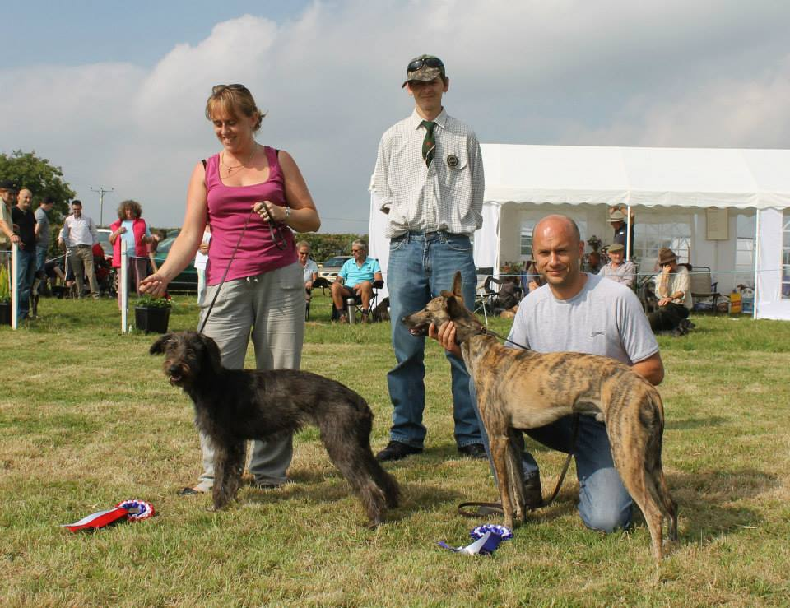
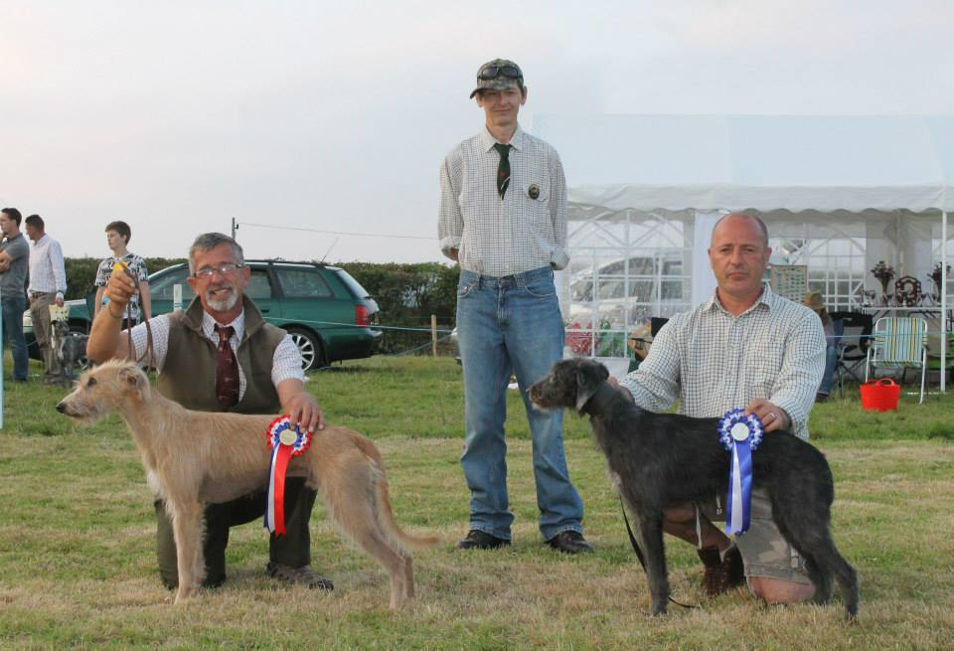
The Terrier ring was judged by Alun Taylor who awarded Alan Phillips ‘Bert’ as Champion Puppy, Reserve went to Tracey Toman’s ‘Mouse’. Terrier champion was awarded to Alan Baulch’s ‘Sonny ‘ with ‘Nell’ ownded by Tracy Toman taking reserve.
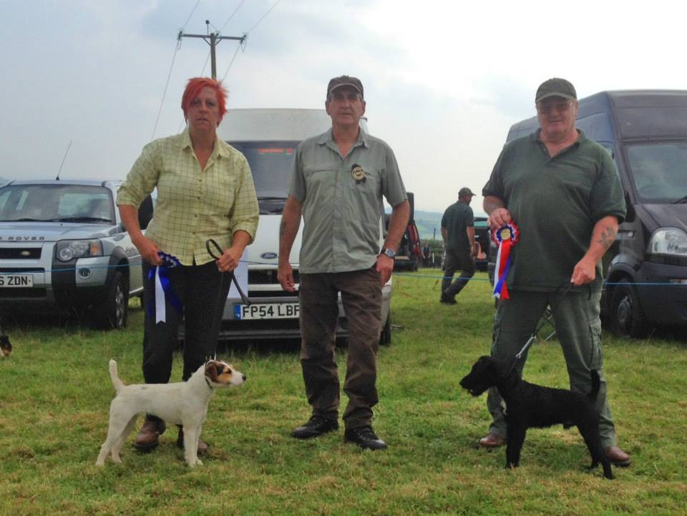
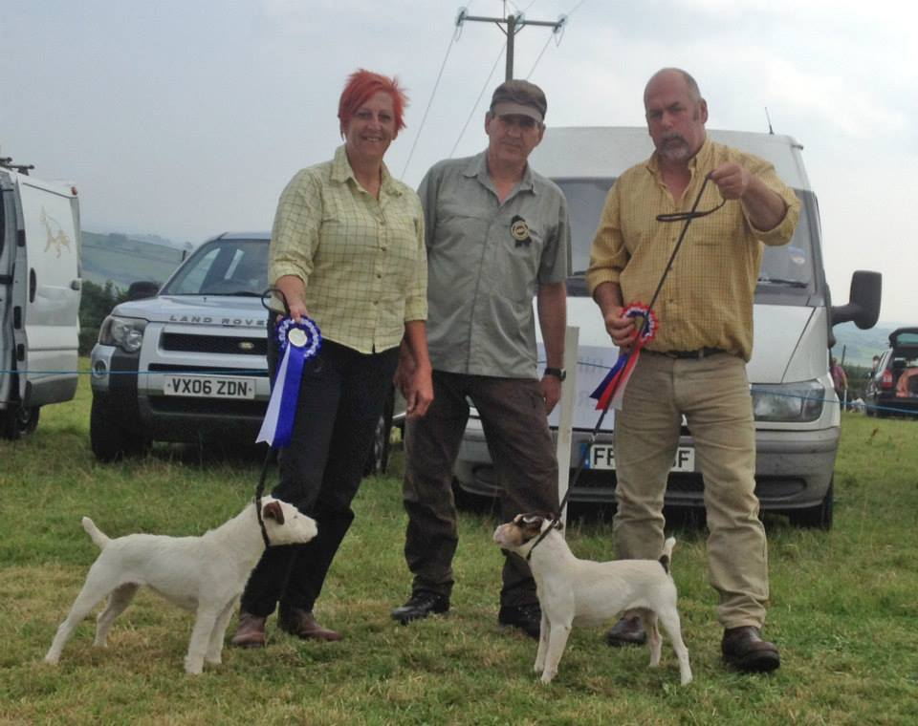

Whippets were judged by Gill Andrews, Whippet champion went to Tish Currans ‘Fallow’ with Lorraine Howes’ ‘Whisper’ taking reserve champion.
