Field Events Results – Stonelands 29-09-18
Whippet Coursing 1st – ‘Trevor’ J Needham
2nd – ‘Breeze’ Denise Southcott
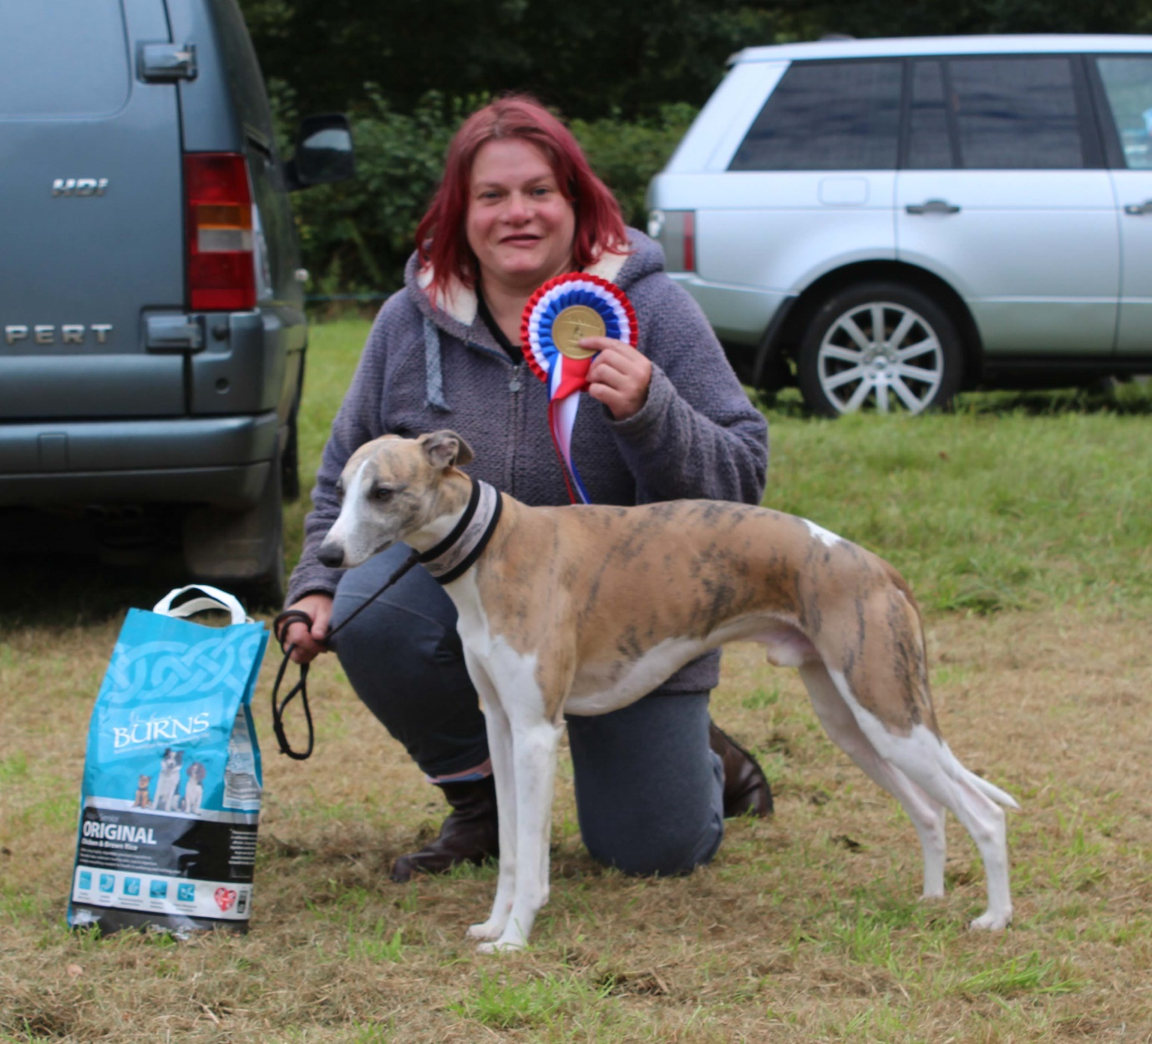

Lurcher U23 Coursing 1st – ‘Sweet Pea’ Nicky Thomas
2nd – ‘Annie’ Lisa Rule
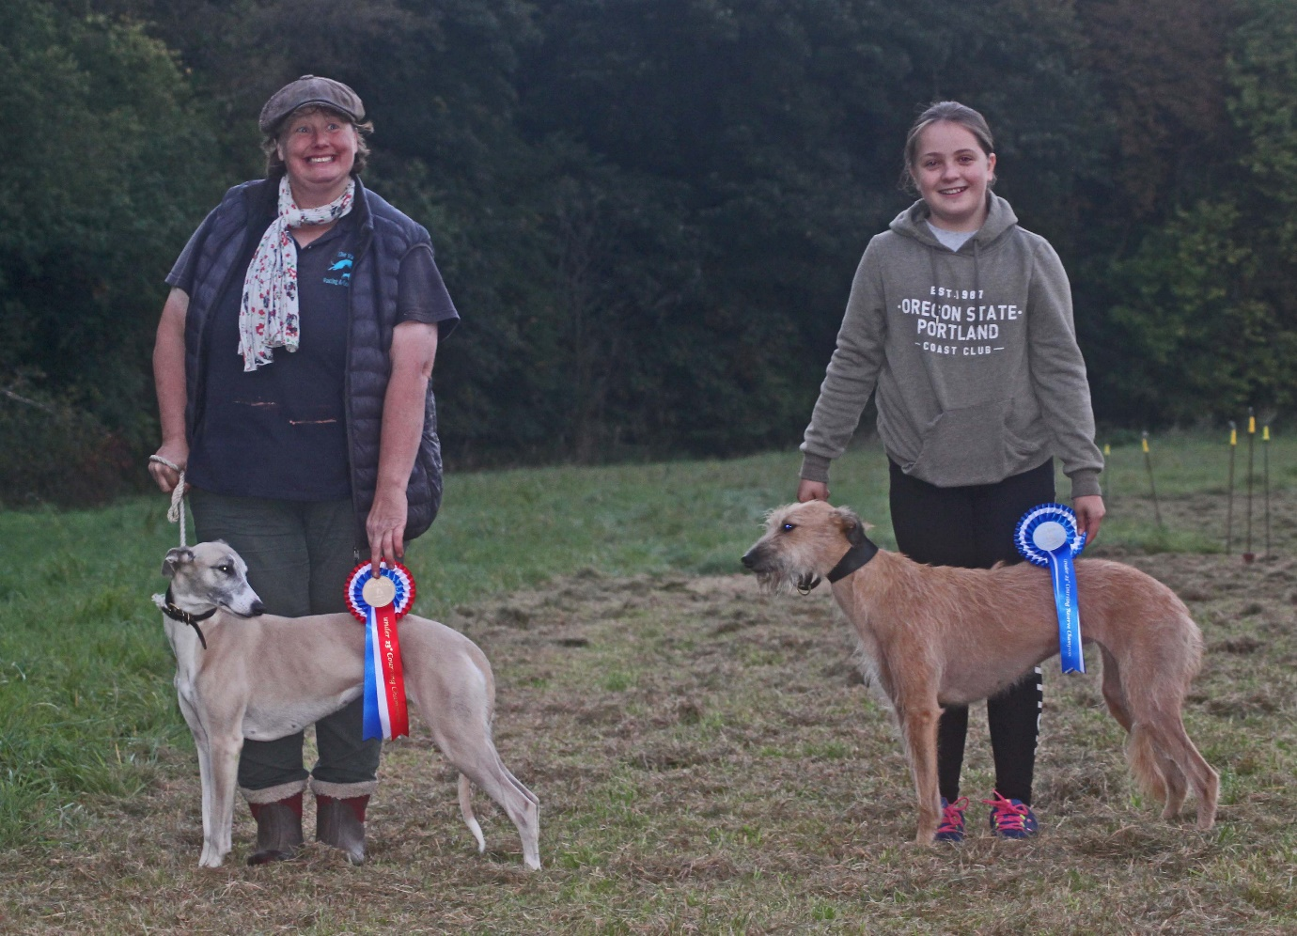

Lurcher O23 Coursing 1st – ‘Pirate’ Lauren Thomas
2nd – ‘Jay’ John Miles
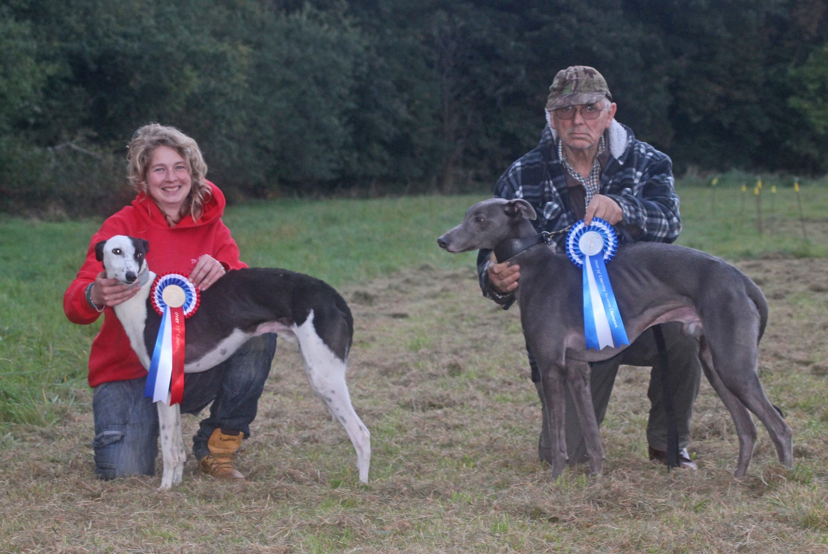

Terrier Hurdles 1st – ‘Digger’ Lauren Thomas
2nd – Dodger
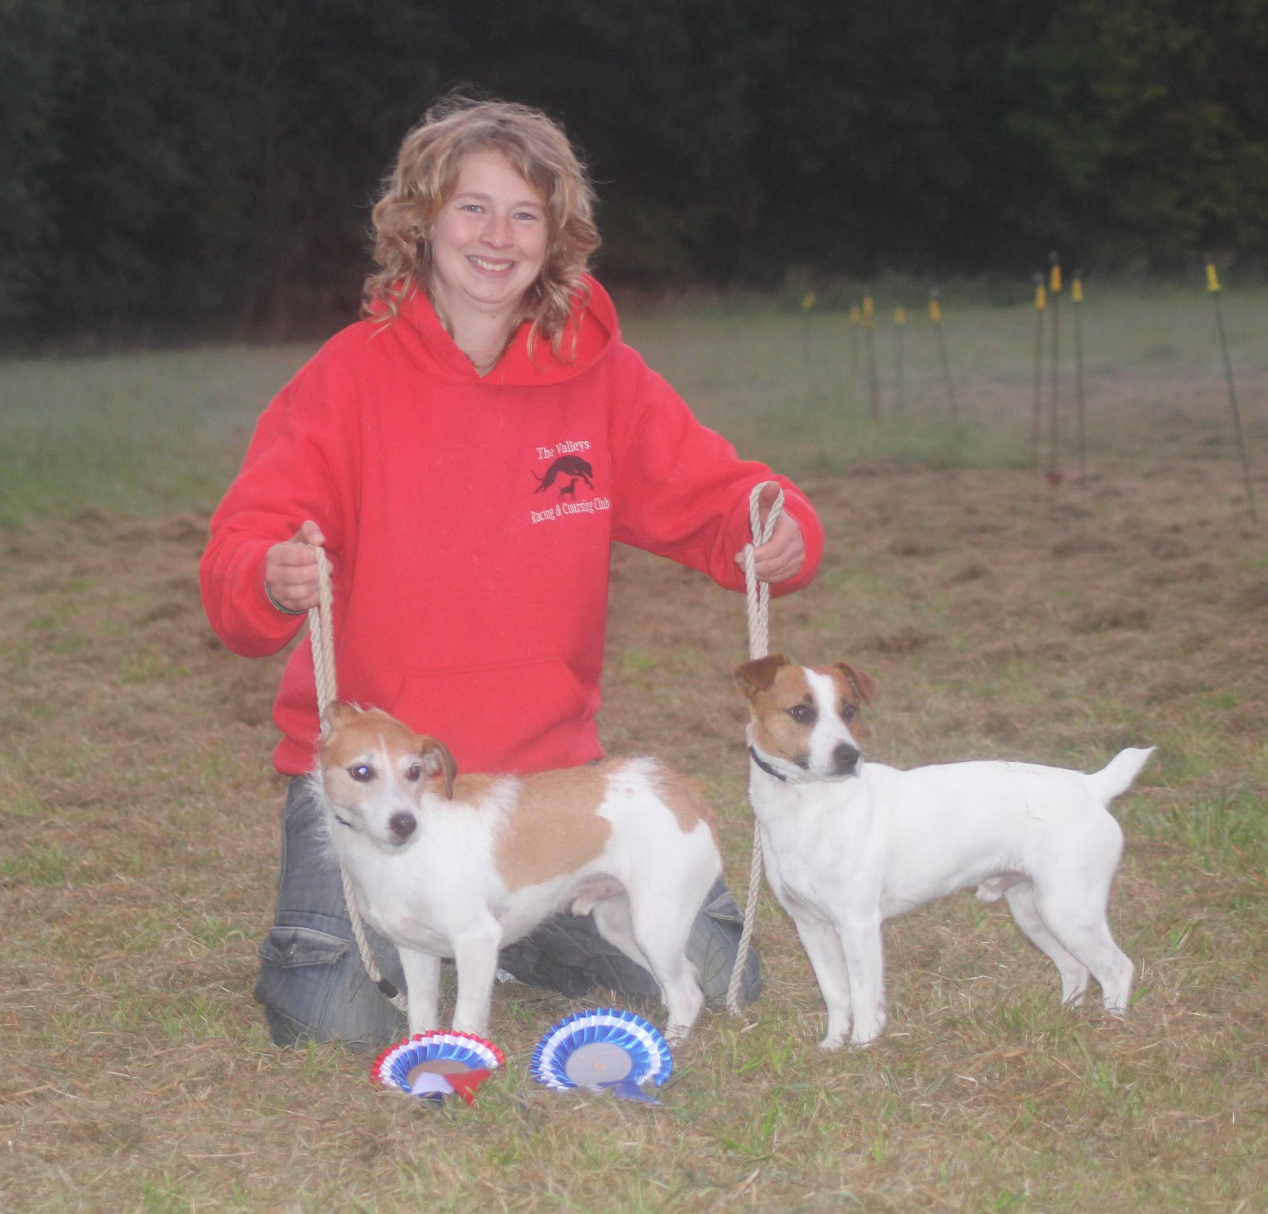

Lurcher U23 Hurdles 1st – ‘Nyla’ Kevin Stanley
2nd – ‘Mocha’ Nicky Thomas
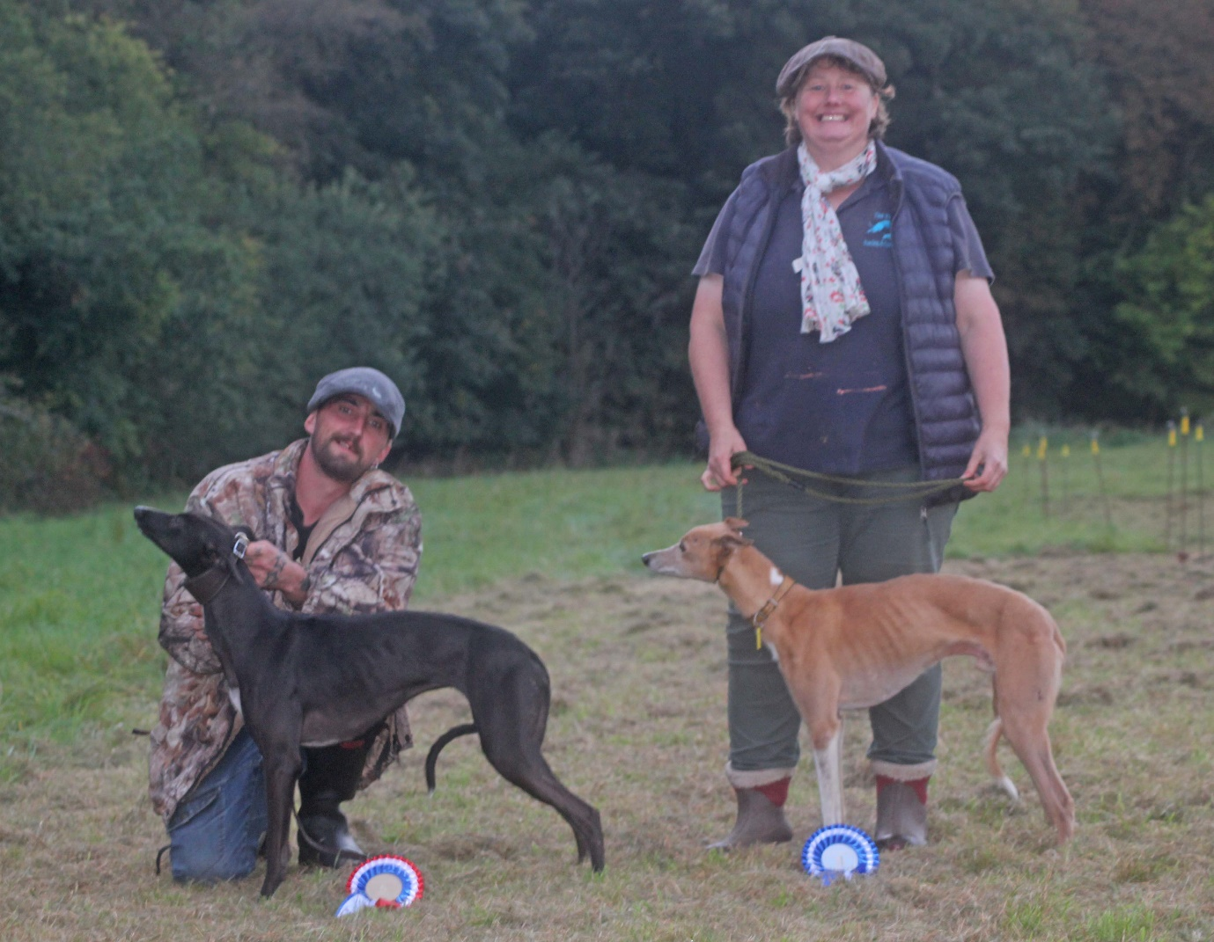

Lurcher O23 Hurdles 1st – ‘Bruce’ Jonathan Spurgeon
2nd – ‘Jay’ John Miles
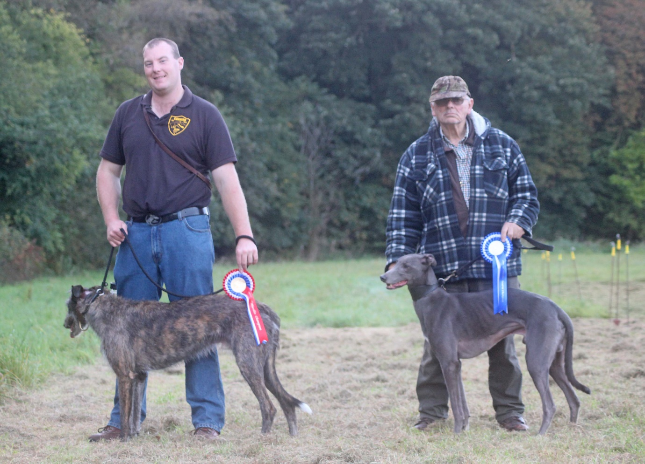

Terrier Racing 1st – ‘Snatch’ Kevin Dominey
2nd – ‘Dilly’ Kevin Stanley
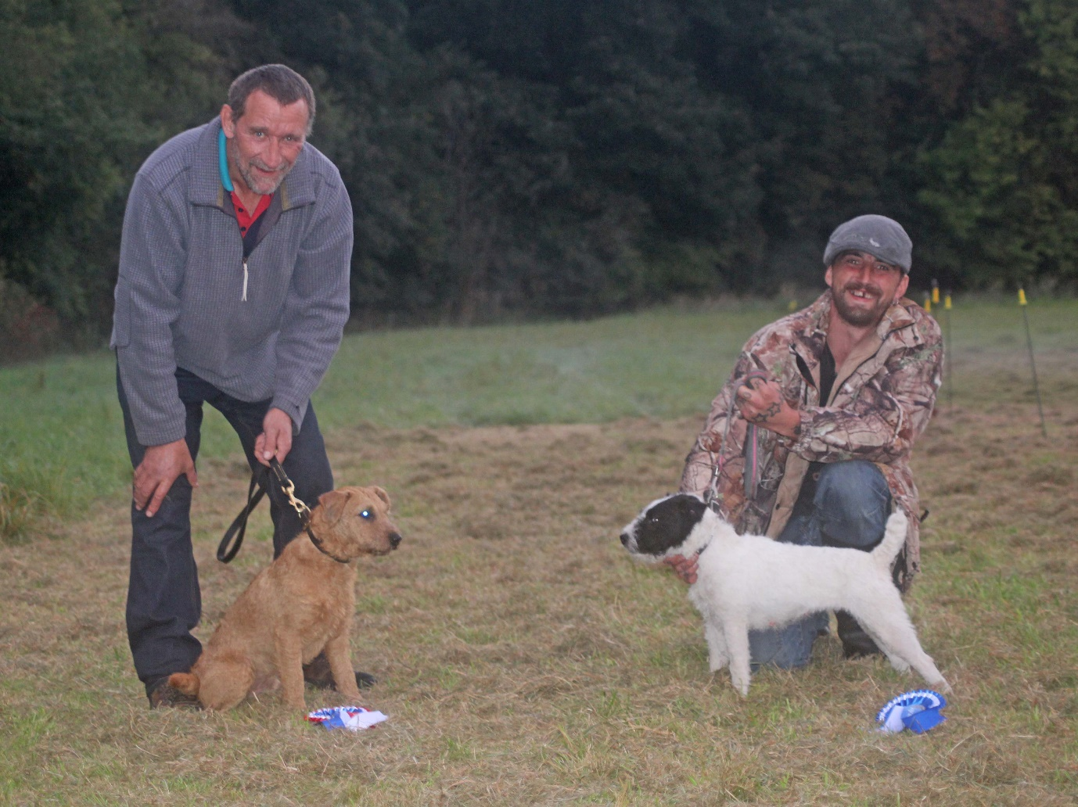

Lurcher U21 Racing 1st – ‘Tish’ Kevin Stanley
2nd – ‘Ben’ Les Baldry

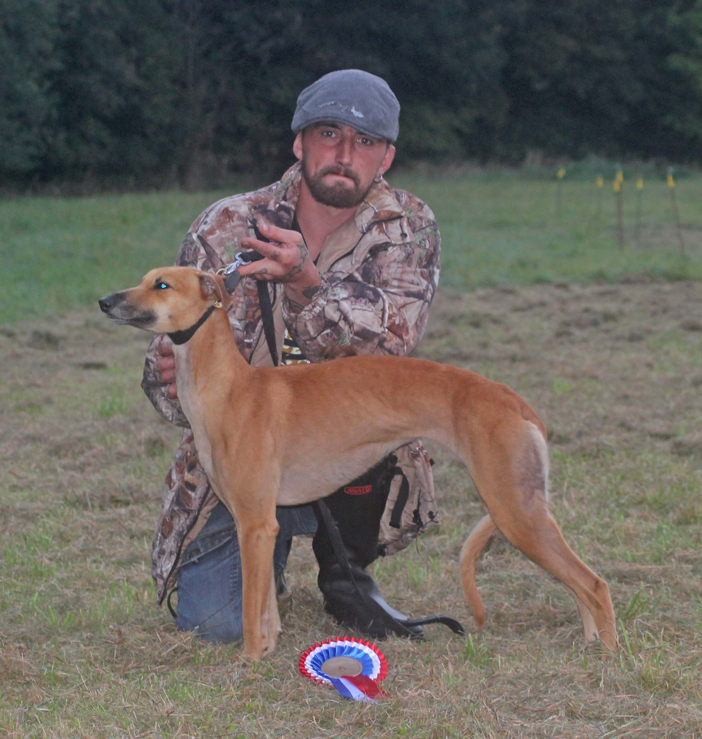

Lurcher U23 Racing 1st – ‘Nyla’ Kevin Stanley
2nd – ‘Chance’ Lauren Thomas
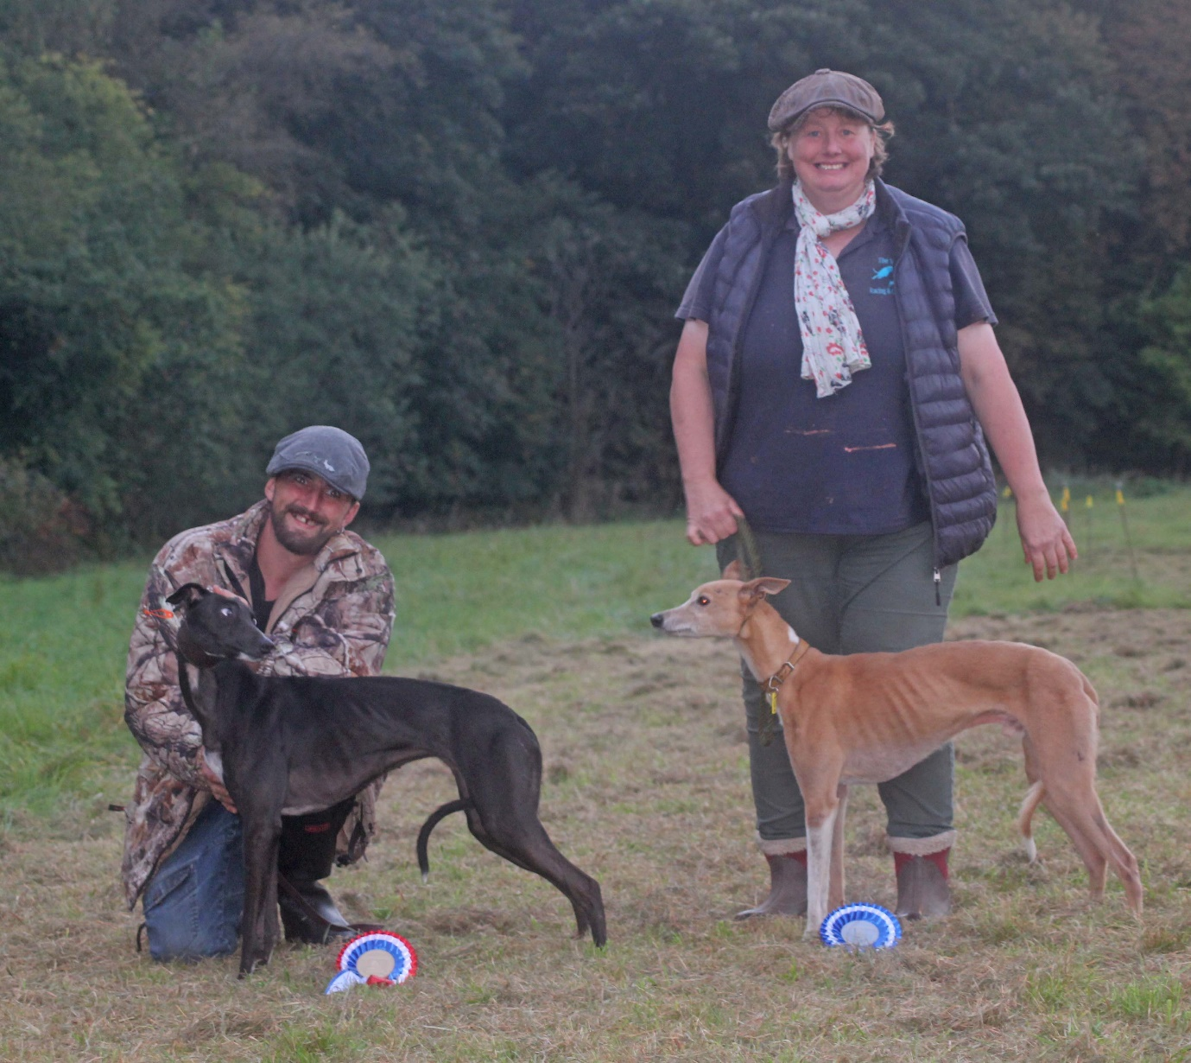

Lurcher O23 Racing 1st – ‘Rave’ Chris Spurgeon
2nd – ‘Pirate’ Lauren Thomas

