Stonelands 2014 Bull X Championship was judged by Mr Martin Toman who awarded Kenneth Danes ‘Cruz’ Champion and Gareth Davies ‘Pip’ Reserve, 3rd went to Joshua Enright’s ‘Duke’ 4th Tracey Beech’s ‘Hazel’ 5th Phil Goss’s ‘Ruby’ and 6th place went to Barry Dann’s ‘Brock’

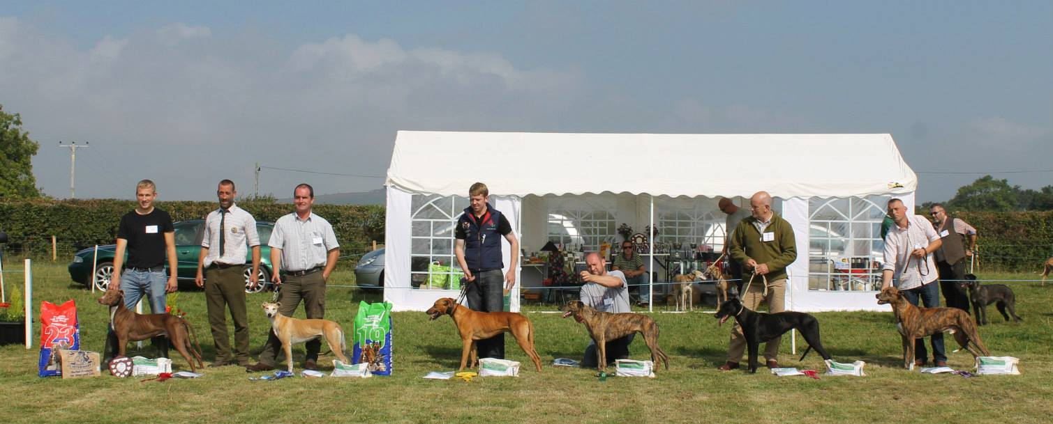
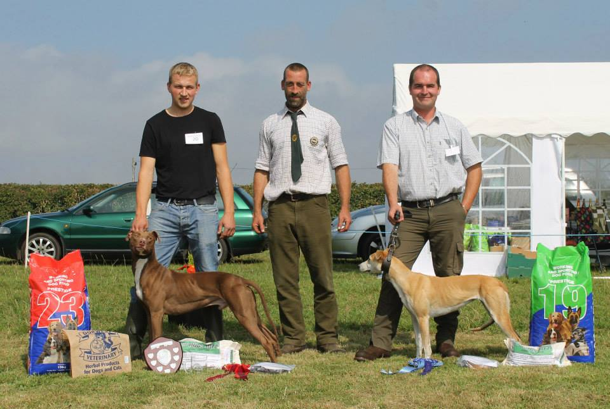

Stonelands 2014 Working Lurcher Championship was judged by Mr Kevin and Mrs Debbie Mumford, this year’s competitors were awarded overall marks from 240 60 points per judge showing and 60 points per judge off the lead obedience. Working lurcher champion was awarded to Jo Williams ‘Maggie’ with Chris Hill’s ‘Red’ taking Reserve, Chris Hill’s ‘Rum’ took 3rd place, 4th was Bail Pennicott’s ‘Fern’ 5th Gareth Davies ‘Pip’ and 6th Aiden Lacey’s ‘Khan’.

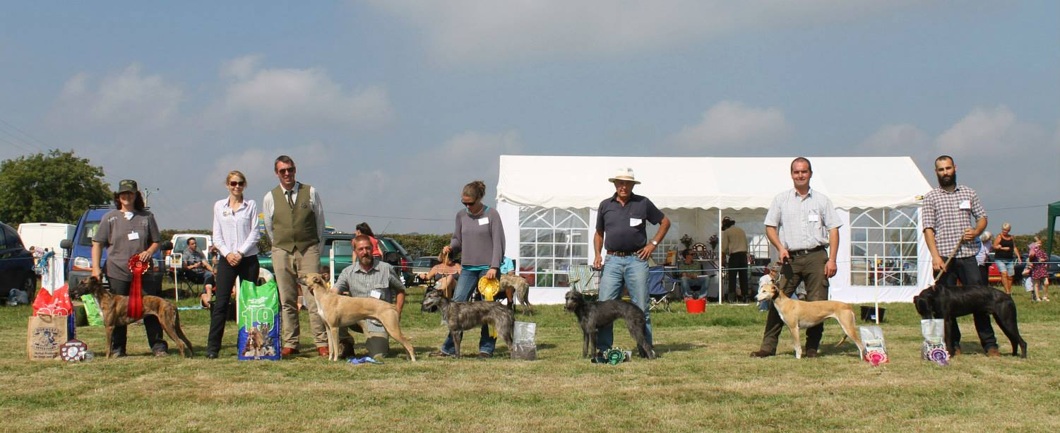
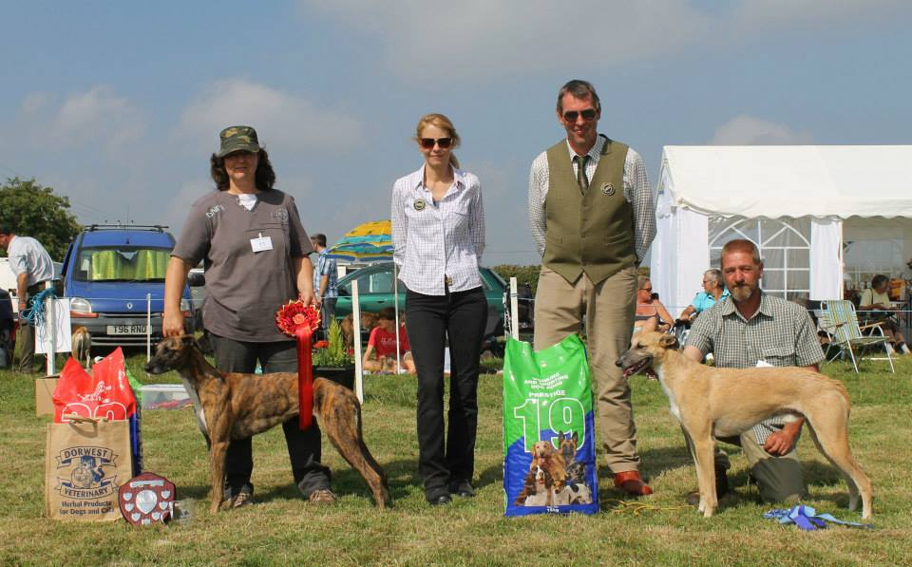

Stonelands Devon Champion of champions was held after the open showing on Sunday 7th September, where dogs who had qualified at a Devon show over the summer competed for top spot and a place at the Supreme British Lurcher Championships at Peterborough on the 13th October. Judging was carried out by Mr Brian Pether who awarded the Devon Champion of Champions to ‘Dolly’ owned by Mark Sherwood, Reserve was then awarded to Ross Body’s ‘Logan’ 3rd place went to Debbie Mumfords ‘Mace’ and 4th to Phil Goss’ ‘Ruby’. Thank you to everyone one who competed in classes and championships over the year to qualify your dogs for these championships, next year Stonelands Autumn show will also host a Champion of Champions for Terriers. For full showing and field events results visit www.southwestlurchershows.weebly.com
